INTERNATIONAL CONFERENCE 7 June 2022 Rotterdam

Biography of the speakers

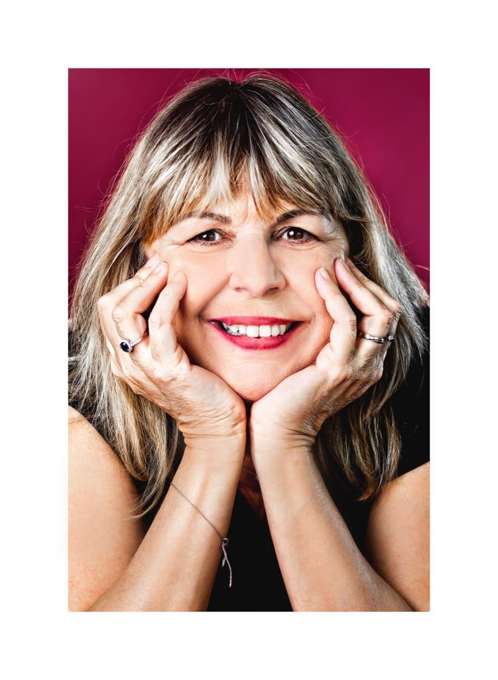  Pascale Franck | Pascale is the Vice-president of the European Family Justice Center Alliance (EFJCA) and the co-director of the Family Justice Center Antwerp, she works for the Flemish government in enrolling the multidisciplinary approach of domestic violence and child abuse. Pascale Franck is criminologist and experienced project manager and team leader, with a demonstrated history of developing and coordinating multi-agency approaches and cross-professional cooperation in the field of gender-based violence, domestic violence and child abuse. Her main tasks are the development, management, monitoring and sustainability of the multidisciplinary centers on domestic violence and child abuse in Belgium and abroad. In this approach she focuses on methodology bringing empowerment of survivors of violence (adults/children). Trauma-informed care and client-centered approach are the lead in this development. During her 32-year career Pascale developed a FJC, a shelter, perpetrator programs and projects for children witnessing and/or experiencing family violence. Pascale is the co-author of the book “One Safe Place for Hope and Empowerment, development of the multidisciplinary approach of domestic violence, child abuse and sexual abuse in European Family Justice Centers”.
Bert is a former Police inspector with 20+ years of experience in child friendly interviewing and in criminal investigations on sexual crimes, trafficking, child pornography, child abuse and other related crimes. Besides an active involvement in national projects focusing on the development of an integral approach of domestic violence, sexual violence and child abuse in the Netherlands, he led several multi-year international projects focussing on developing and implementing a multi-agency approach on gender-based violence and child abuse. As project leader Bert led the by the EU funded project ‘Family Justice Centers in Europe’ and was responsible for the development and implementation of Family Justice Centers (FJC) in five European countries. Bert is the co-author of the book “One Safe Place for Hope and Empowerment, development of the multidisciplinary approach of domestic violence, child abuse and sexual abuse in European Family Justice Centers”.  Currently Bert is the President of the European Family Justice Center Alliance (EFJCA). He also operated as a case manager at the Sexual Referral Center (CSG) in the region of Zwolle, the Netherlands. He has 30+ years of professional experience in policing, policymaking and project management with a focus on domestic violence, sexual violence, human trafficking and child abuse. | 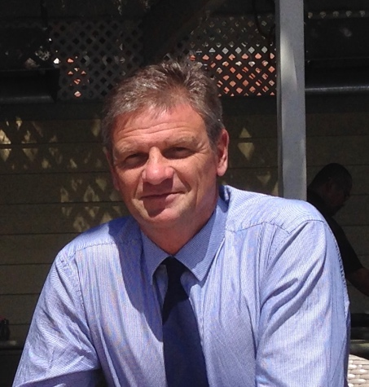  Bert Groen
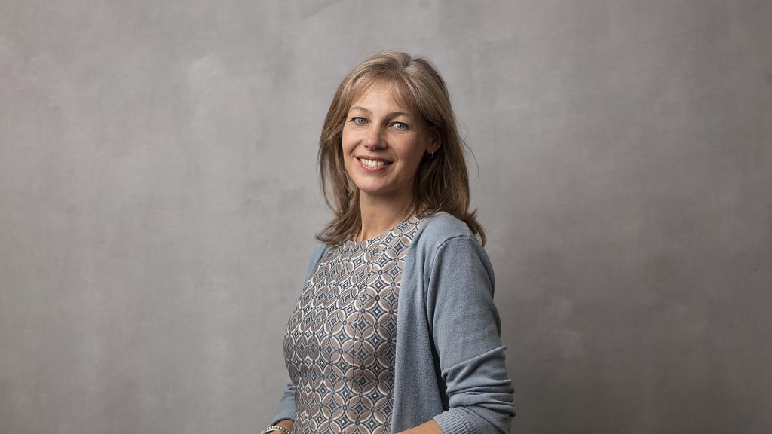  Judith Bokhove | Judith Bokhove has been an alderman in Rotterdam since 5 July 2018 on behalf of GroenLinks. She is responsible for the Mobility, Youth and Language portfolio.  On behalf of the Municipality of Rotterdam, she is a member of the Traffic and Transport Board of the Metropolitan Region of Rotterdam The Hague (MRDH). After her studies, Bokhove worked as a speech therapist until her position as alderman. From 2000 she did this in her own independent speech therapy practice in Rotterdam-West. Over the years she has held various (board) positions to improve the quality of the profession. Judith was also active together with her neighbors in the Spoortuin, a green project in her neighborhood in Rotterdam-West.  Bokhove has been a councilor in Rotterdam since 2010 for the GroenLinks faction. From 2014 she led the GroenLinks faction and chaired the council committee for Care, Education, Culture and Sport and the zoning plan committee. She spoke on behalf of GroenLinks on the topics of building, housing and outdoor space.
Shantie is a writer, theater maker, columnist, storytelling fashionista and a creative public administrator. Central in all her work is the power of stories, imagination and the impact of words. She loves to make invisible stories visible and has a soft spot for the 'underdog and the silent heroines'. Because they often carry the most beautiful and powerful stories with them. Themes such as identity, diversity, women's rights and emancipation are often central to her work. It is her passion to improve the position of girls and women worldwide. She is the author of 'De Kier', a captivating novel born of the tragic death of the young Zafira Khan in Rotterdam. The theme of domestic violence, in particular the problem of hidden women, is central without being presented raw. | 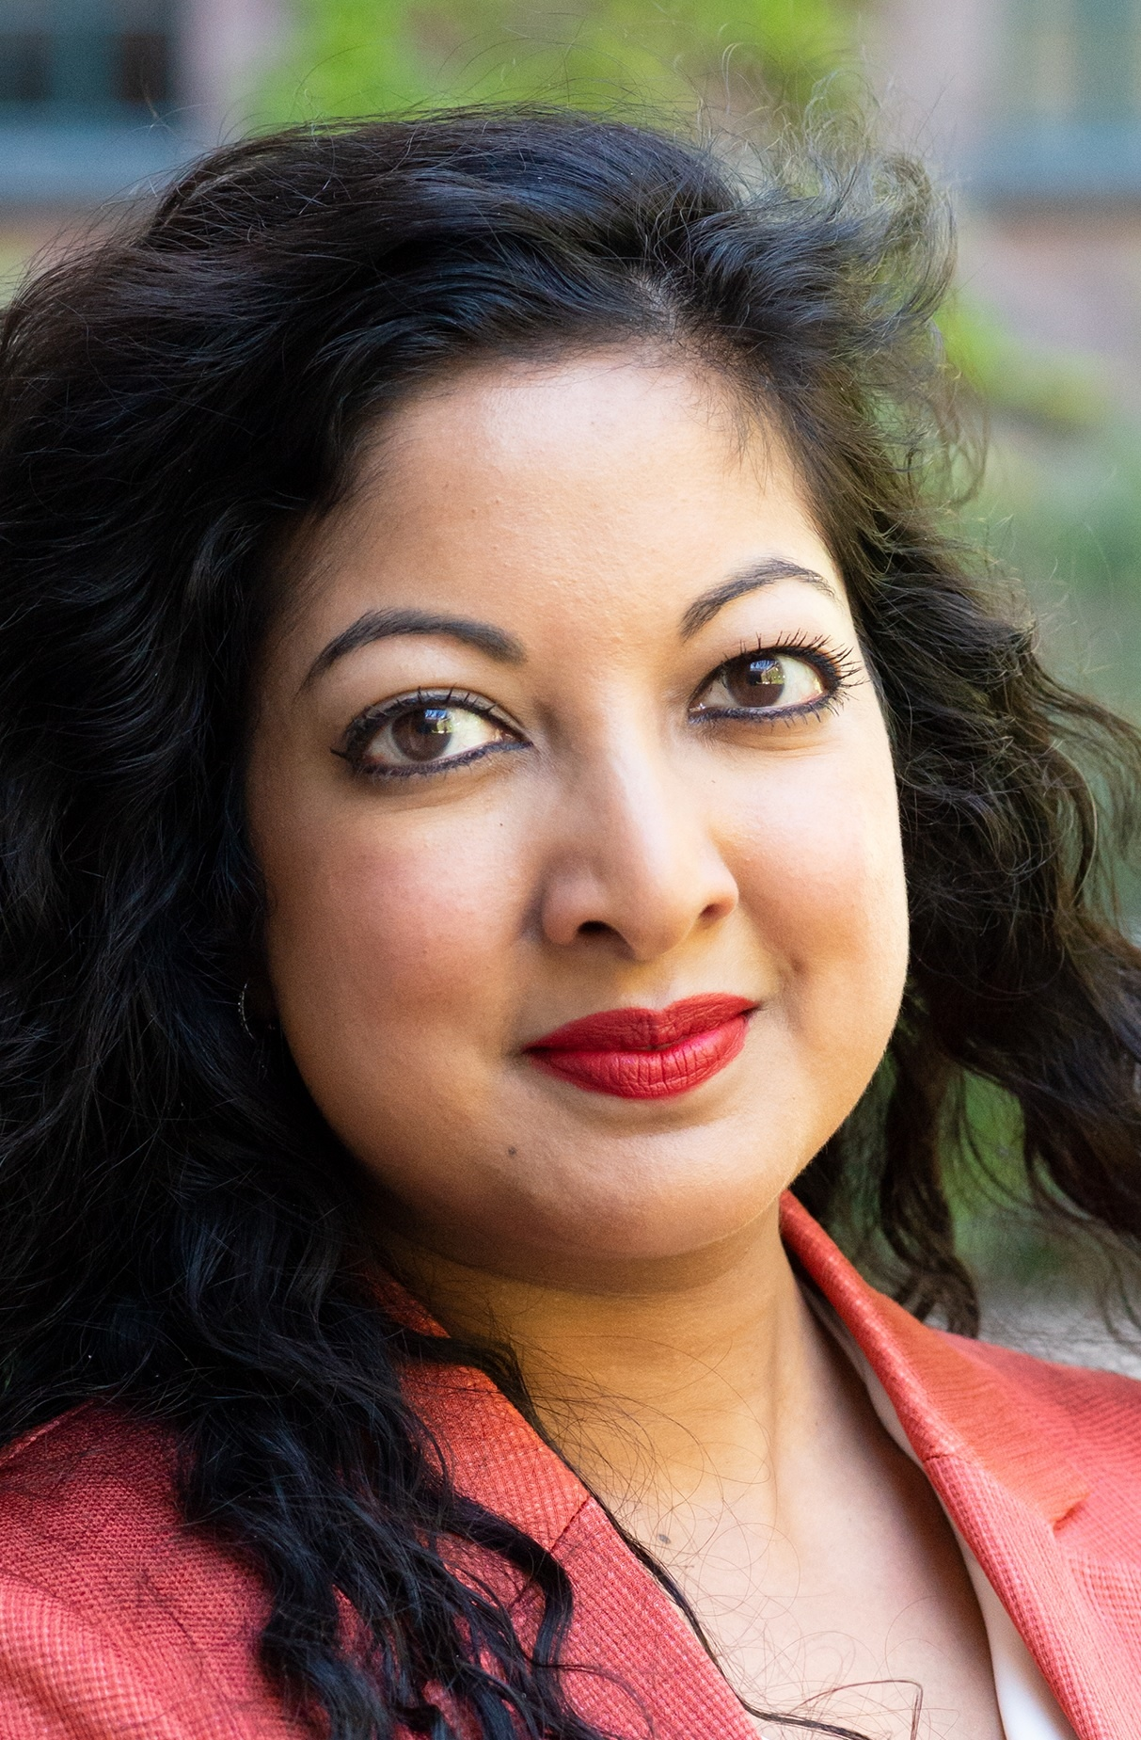  Shanti Jagmohansingh
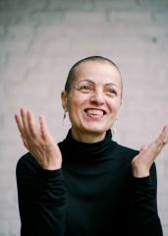  Triene-Mie Le Compte | Triene-Mie Le Compte was a victim of intimate terror. She kept silent for 20 years, until finally, with outside help, she left with just one small suitcase. She knows from her own experience how big the taboo on intimate violence is and how difficult it is to talk about it, so she now gives lectures, radio and TV interviews, and collaborates with organizations. Her mission is to bring a message of hope. In her book 'When love becomes survival – the many faces of intimate partner violence', which she wrote together with scientist and mediator Anne Groenen, you can read her life story and everything one needs to know about intimate terror. On April 7, 2022 this book won the Dutch Carla Aztema audience award.
Anne is a Social worker, PhD in criminology and mediator. She’s also the head of the Center of Expertise Resilient People at University Colleges Leuven Limburg, researcher and lecturer at KU Leuven. Anne is promotor and researcher in several (inter)national projects concerning domestic violence and stalking and has been involved is studies about the Family Justice Centers in Flanders. She was also a member of the project group on Intimate Terrorism in the Netherlands and author of several publications about domestic violence, stalking and other forms of violence. | 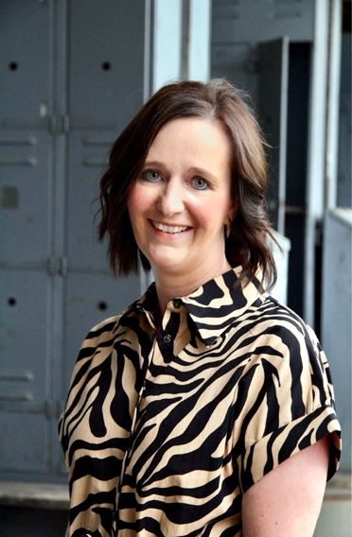  Anne Groenen
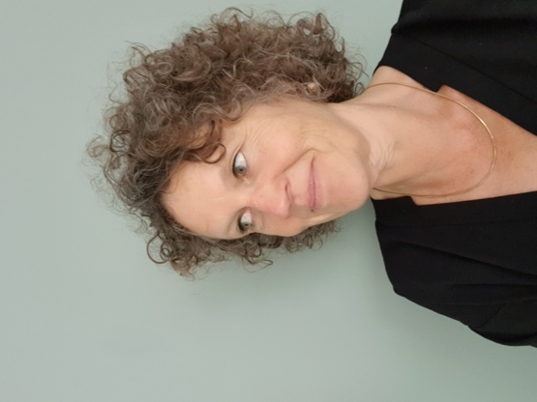  Gerda De Groot | Gerda is a member of the staff of Fier and is involved in processes of change, substantive quality and working method development. She’s a member of the Multidisciplinary working group of www.chatmetfier.nl (a live chatgroup for survivors of all kinds of violence), coordinator of the Sexual Violence Referral Center at Friesland, regional project leader on Intimate Terror and systemic therapist. In addition to her work at Fier, she has her own practice as a systemic therapist.
Serife is experienced trainer at the Academy of Sterk Huis, with the focus areas on Safety, Honor related violence and Sexuality. | 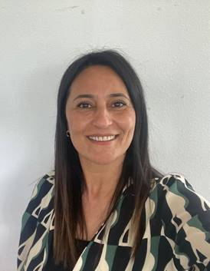  Serife Cetin
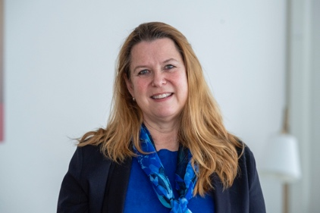  Christine Clement | Christine is an experienced manager, consultant and researcher on violence in dependent relationships. She likes to tackle complex issues with a large dose of creativity, curiosity, analytical skills and positivity. She has been working as manager of Filomena for over a year and with the help of her team she has managed to convert it from a pilot project into a full-fledged Family Justice Center. Her mission is to help Filomena grow into a knowledge center in the field of complex violence in dependent relationships. Her dream is to develop and test new initiatives based on 'facts and faces', the combination of research and experiential knowledge.
Katalin is a legal officer at the European Commission in the unit responsible for gender equality. She works more specifically on matters related to violence against women. She has a background in equal treatment and fundamental rights. | 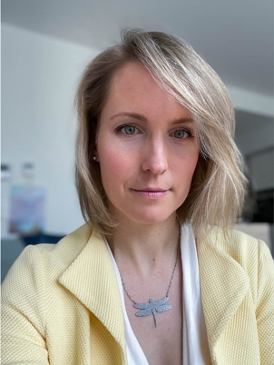  Katalin Szilas
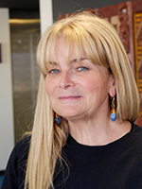  Dorothy Adams | Dorothy served as the Chief Executive Officer, at the New Zealand Social Wellbeing Agency between 2020 and 2021. Prior to this, she was the Acting Chief Executive Officer at the Social Investment Agency, which she led from its inception in July 2015. From 2008 to 2015 Dorothy was responsible for the Ministry of Social Development’s data, analytics and evidence hub. Before joining the Ministry of Social Development Ms. Adams worked in local government for ten years specializing in policy and governance. She has also held senior roles in the Department of Labour, NZL Employment Service and was an advisor to the Minister of Employment. Ms. Adams has a Master of Public Administration from Monash University and an LLB from Victoria University of Wellington. She is an Enrolled Barrister and Solicitor of the High Court of Wellington. In May 2021, Dorothy joined the OCDE to pursue projects focused on better use of data and evidence to improve social policy and programme design.
Jane is Professor of Public Protection at the University of Gloucestershire with a specialism in homicide, coercive control and stalking. In addition to her academic work she maintains a diverse portfolio of professional and case work. She works with families bereaved through homicide helping them with criminal justice and other processes; she advises homicide review panels, as well as chairing statutory domestic homicide reviews; she advises police on current and cold investigations, and crisis risk assessments; she trains police and other professionals in assessing threat and risk in cases of domestic violence and recognizing and identifying suspicious deaths. Her most recent book In Control: dangerous relationships and how they end in murder explains her work in creating the "Homicide Timeline' that shows how and why homicide risk may be escalating in cases of coercive control and stalking. Her latest work has been in tracking risk escalation in domestic abuse related suicide, and a framework for identifying so-called 'hidden homicides', that is sudden and unexpected deaths that have a history of domestic abuse. | 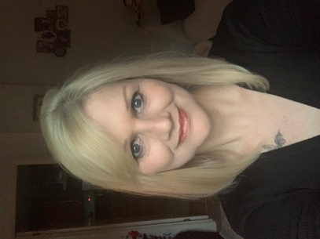  Jane Monckton-Smith
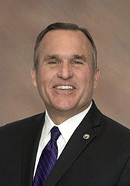  Casey Gwinn | Casey is the visionary behind the Family Justice Center Movement, first proposing the concept of the Family Justice Center model in 1989. He is a national expert on domestic violence dynamics, including investigation and prosecution, the handling of non-fatal strangulation cases, and is one of the leading thinkers in the country on the science of hope. Casey was the elected San Diego City Attorney from 1996-2004 and founded Camp HOPE America in 2003.
Gael Strack is the Chief Executive Officer and Co-Founder of the Alliance. Gael is a national expert on domestic violence and strangulation. Prior to this position, Gael was the founding director of the San Diego Family Justice Center, former prosecutor with the San Diego City Attorney’s Office, defense attorney, and deputy county counsel. | 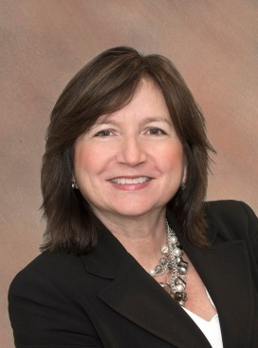  Gael Strack
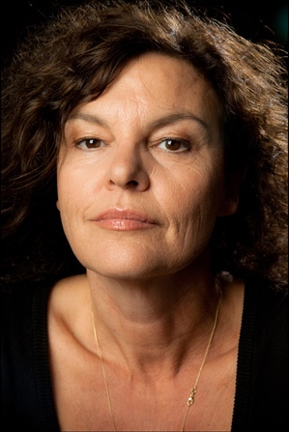  Hilde Van Mieghem | Hilde Van Mieghem (Antwerp, 1958) makes her debut as 'Christiane' in the feature film Vrijdag (Hugo Claus, 1980). In the same year she graduated from Studio Herman Teirlinck. In the theater Van Mieghem could be seen in Lulu (Jean-Pierre Dedecker, 1991); Desire among the elms (Ivo Van Hove, 1992); Les Amants Puérils (Moshe Leiser, 1993); Crusades (Ivo Van Hove, 2004); I am a Mistake (Jan Fabre, 2007); Children of the sun (Ivo Van Hove, NTGent / Toneelgroep Amsterdam, 2011/2012); The Hanged (Josse De Pauw (2011). She plays important roles in some sixty Belgian and international films and TV series.  Since 1997 she has focused on developing and directing her own film projects. She is directing a three-part documentary series about domestic violence for the Flemish channel Canvas: Als je eens wist/If you once knew (2019-2022). Her debut novel De drie Duifkes will be published this spring by De Arbeiderspers Publishers.
Ilona is health care psychologist, working as Head of Development of programs for Sterk Huis. Specialist in the field of domestic violence, honor-related violence, juvenile prostitution and child abuse. Author of 'The Colors of Eve and Zahir'. Trained as a trauma therapist, MBT therapist. She is experienced in working with (acute) psychiatric problems combined with complex behavior in relation to trauma, writing policy and methodologies and a lot of experience with psychodiagnostics. | 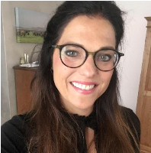  Ilona Brekelmans
Saskia de Veld | Saskia is health care psychologist, working as Program Coordinator of the Psychotrauma Center of Sterk Huis. Originally a family pedagogue, started within women’s counseling and specialized in the field of domestic violence, child abuse, honor-related violence, loverboy-problems and is trained as a trauma therapist and MBT therapist. She’s experienced in analyzing complex issues within youth and women’s care and a has a lot of experience with psychodiagnostics.
Arno is professor in antisocial behaviour, psychiatry and society at Tilburg University and work as a clinical psychologist in regular and forensic mental health care with violent offenders. The last decade he developed several treatment programmes for perpetrators of domestic violence. He pays special attention to the role of experience workers and to what it takes for therapists to build an effective therapeutic alliance with offenders. | 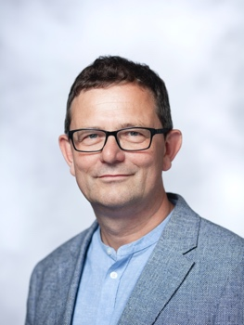  Arno Van Dam
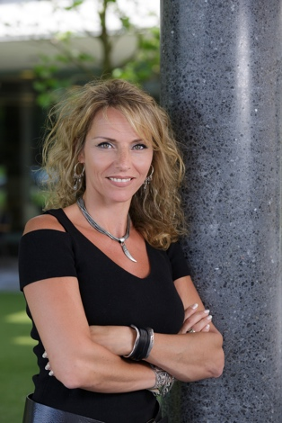  Madeleine Rijckmans | Based on the conviction that practice needs science to develop and science needs practice, Madeleine Rijckmans, both as a researcher and as a practitioner, is involved in antisocial and transgressive behavior within forensic mental health care. Madeleine works at Fivoor as a psychotherapist / health care psychologist at the forensic outpatient clinic and as a senior scientific researcher at the Science & Treatment Innovation department. She is also duo chair of the national expert platform Antisocial Behavior of the Knowledge Center for Personality Disorders and is associated with the (international) minor and master of Clinical Forensic Psychology at Tilburg University, where she gives guest lectures. Madeleine has an ISST advanced level certification (senior schema therapist) and is an EMDR practitioner.
Trees is a health care psychologist in training to become a clinical psychologist. She has been working at Fier since 2016 and provides both diagnostics and treatment for people who are victims of violence in dependent relationships. As part of her training, she is currently seconded to mental health care Friesland and works in a forensic psychiatric department. | 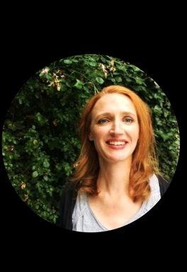  Trees Kelder

